**EXPERIMENT 3:**

**Aim:**

To familiarize DDL Commands- ALTER, DROP, TRUNCATE, RENAME

**CO 1:**

Design and build a simple relational database system and demonstrate competence with the fundamentals tasks involved with modelling, designing and implementing a database.

**Procedure:**

1. Create a table ‘emp’ with attributes empno int(4)as primary key, ename char(10), hiredate, salary, commission and insert the following 5 rows of data:

| 101 | Ramesh | 17-Jan-1980 | 5000 |  |
| --- | --- | --- | --- | --- |
| 102 | Ajay | 05-Jul-1985 | 5000 | 500 |
| 103 | Ravi | 12-Aug-1981 | 1500 |  |
| 104 | Nikesh | 03-Mar-1983 | 3000 | 700 |
| 105 | Ravi | 05-Jul-1985 | 3000 |  |

* Database Creation:

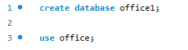



* Table Creation:

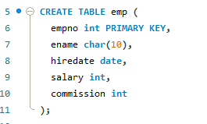 

* Insertion of tables :

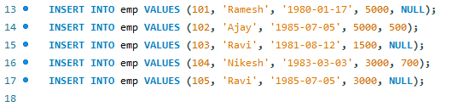

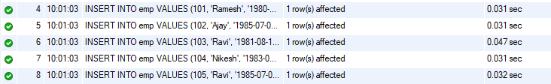

* Viewing the entered Data:



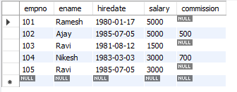

1. Add check constraint (Salary >=1500)

 

1. Add Check Constraint (length(empno<=3))

 

1. Modifying the structure of tables:
2. Add new columns: sal int)





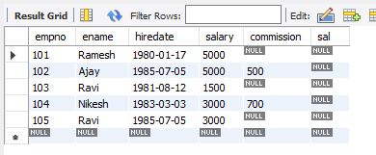

1. Dropping a column from a table: sal





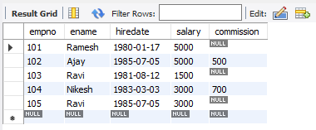

1. Modifying existing column :ename varchar(15)

 

1. Renaming the tables: emp to emp1

 



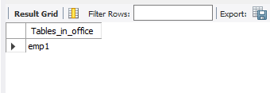

1. truncating the tables:emp1

 

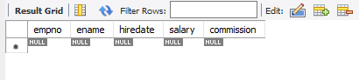

1. Destroying tables:emp





